Logistics Regression:
• used to do classification (not regression)
• Linear regression -> with some tweaks.
• Linear Equation -> w1x1 + w2x2 + .... + wn*xn => score
• score -> function(sigmoid function) -> Probability score ( 0 & 1)
• Binary classification -> with the help of prob score, we classify the results between Class A and Class B.
• PS => < 0.5 = Class A
• PS => > 0.5 = Class B

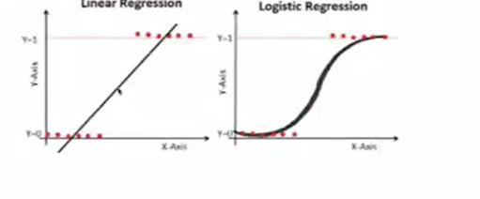
Sigmoid function
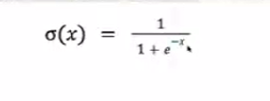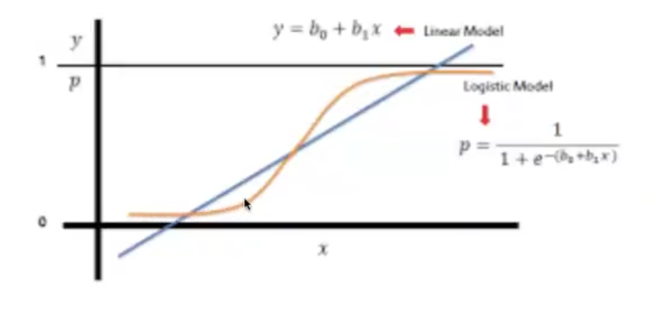

Cost function: To minimise the error rate. In regression
(means improving the quality of the weights/ coefficients)
Log Loss / Binary cross-entropy loss
MLE (maximum likelihood estimation):
• Optimise the model
• Weights adjustments.
• Gradient Descent -

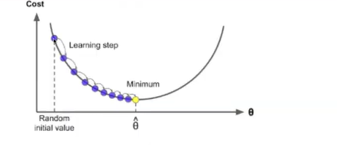
Multi-class classification:
• Class A, Class B, Class C
• One vs rest
• Class A + Others (class B + class c)
• Class B + Others(Class A + class C)
• Class C + Others(Class A + class B)
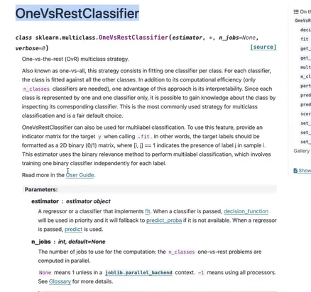
Multi class
from sklearn.linear_model import LogisticRegression
from sklearn.multiclass import OneVsRestClassifier
clf = LogisticRegression()
ovr = OneVsRestClassifier(clf)
ovr.fit(X, y)
Binary class
from sklearn.linear_model import LogisticRegression
clf = LogisticRegression()
clf.fit(X, y)

